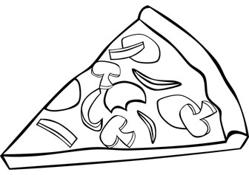
pizza

--------------------------------------------------------------------------------------------------------------------------------------
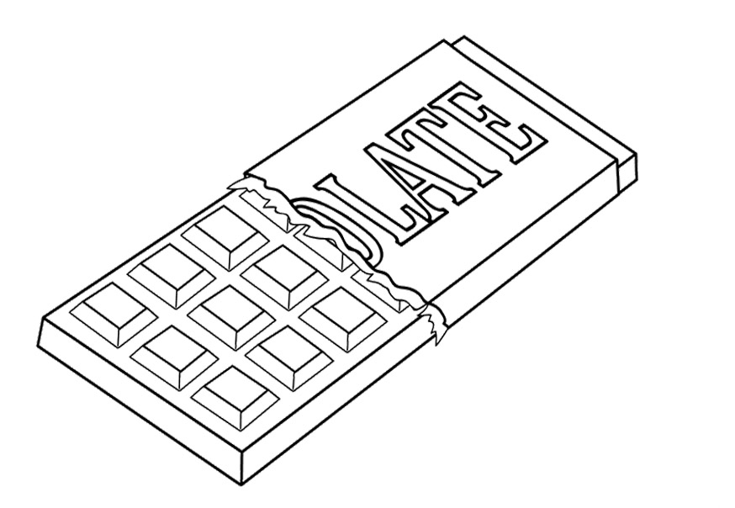chocolate

apple

--------------------------------------------------------------------------------------------------------------------------------------

orange
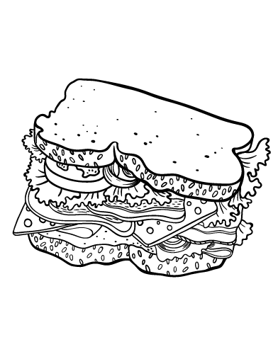
sandwich

-------------------------------------------------------------------------------------------------------------------------------

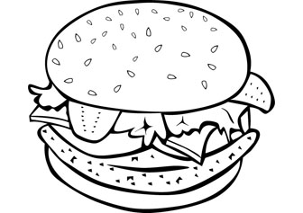

hamburger

ice cream
--------------------------------------------------------------------------------------------------------------------------------------

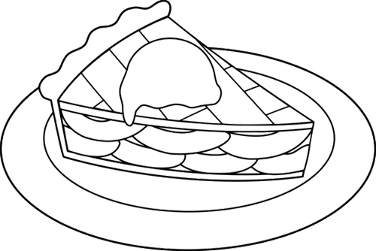

apple pie
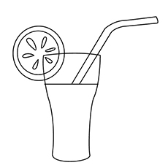
juice

--------------------------------------------------------------------------------------------------------------------------------------

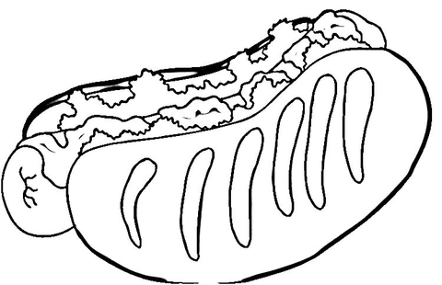

hot dog

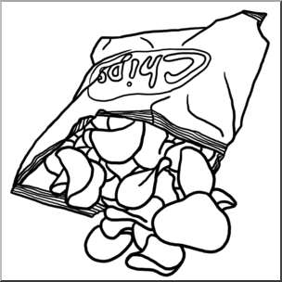
chips
-----------------------------------------------------------------------------------------------------------------------------

cake
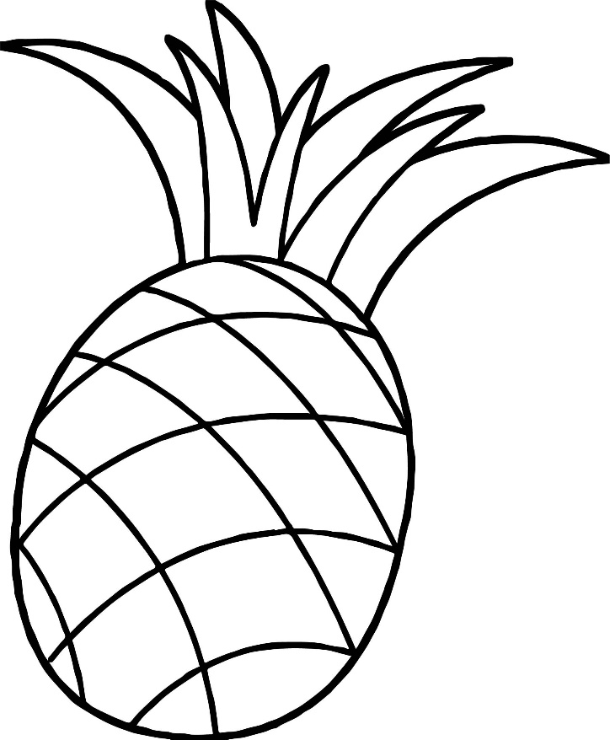
pineapple
-------------------------------------------------------------------------------------------------------------------------------------

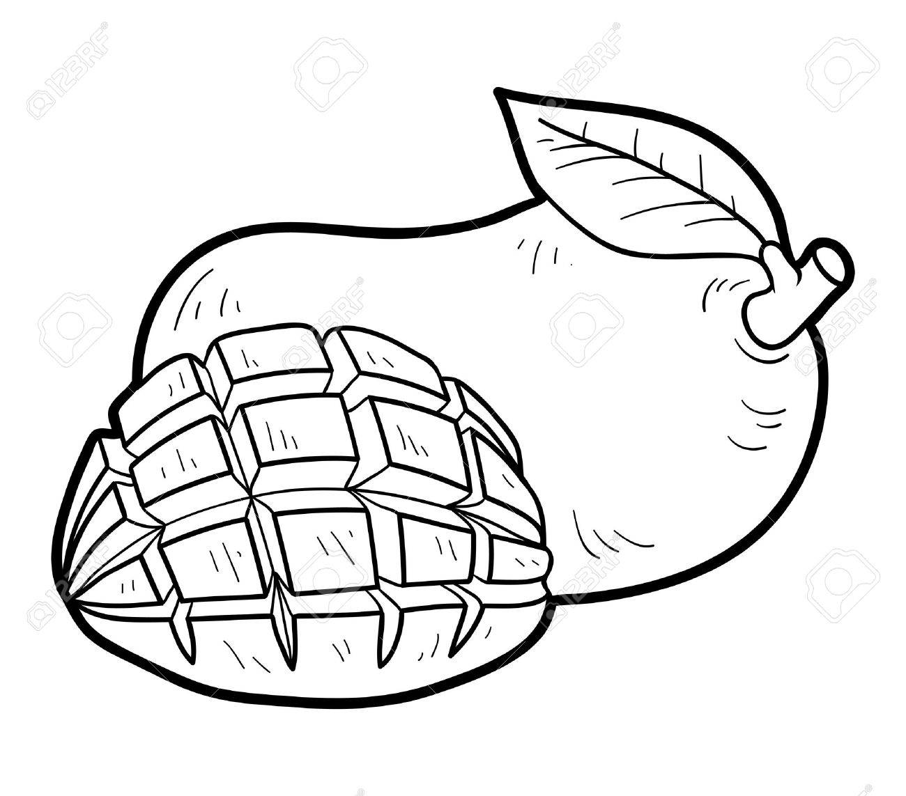
mango

melon

----------------------------------------------------------------------------------------------------------------------------------

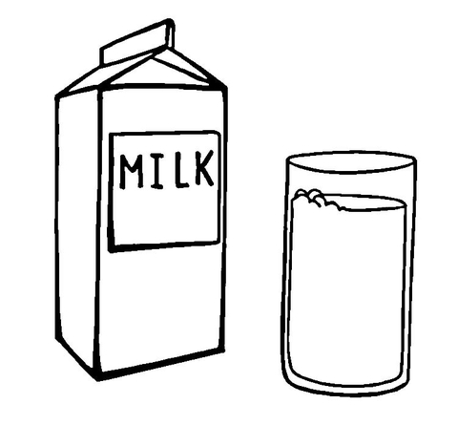

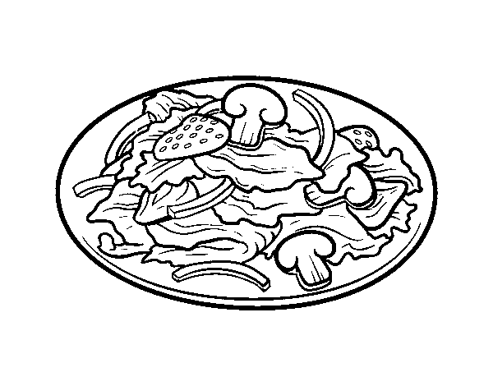
salad

--------------------------------------------------------------------------------------------------------------------------------------

